“CLEANING THE WORLD WITH ACTIVATED CARBON”

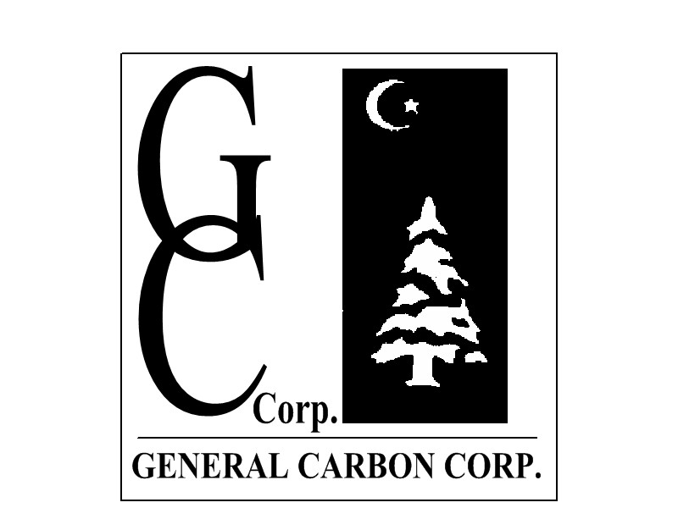

GC 4x8SN
nut shell granular activated carbon

GC 4x8SN granular activated carbon is ideal for most air purification purposes. Made from selected grades of nut shells, its superior level of hardness makes it cleaner than most other carbons and gives it longer life expectancy. This, combined with its high activity level, makes it well suited for use in any kind of carbon filter or system.

Specifications
Mesh Size - 4x8, %: 90 (min)
Greater than No. 4, %: 5 (max)
Less than No. 8, %: 5 (max)
CCl4 Activity, %: 60 (min)
Hardness No., %: 95 (min)
Ash Content, %: 8 (max)
Moisture, % (as packaged): 5 (max)
Typical Density, g/cc: 0.45-0.50

*Standard packaging is in 55 pound vinyl bags. Other packaging is available upon request.
Caution!
Wet activated carbon removes oxygen from air causing a severe hazard to workers inside carbon vessels. Confined space/low oxygen procedures should be put in place before any entry is made. Such procedures should comply with all applicable Local, State and Federal guidelines.

33 Paterson Street, Paterson, New Jersey 07501 Tel: 973 523 2223 Fax: 973 523 1494
www.generalcarbon.com sales@generalcarbon.com

